**Table used**



**Sum Trigger**

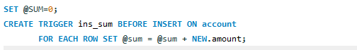

After select @sum as ‘total’;

**Less than 0 greater than 100 update trigger**

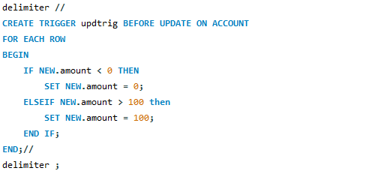

**Insert a row into table and use the update statement to see working of trigger**

